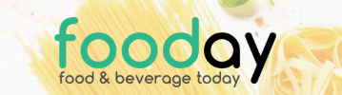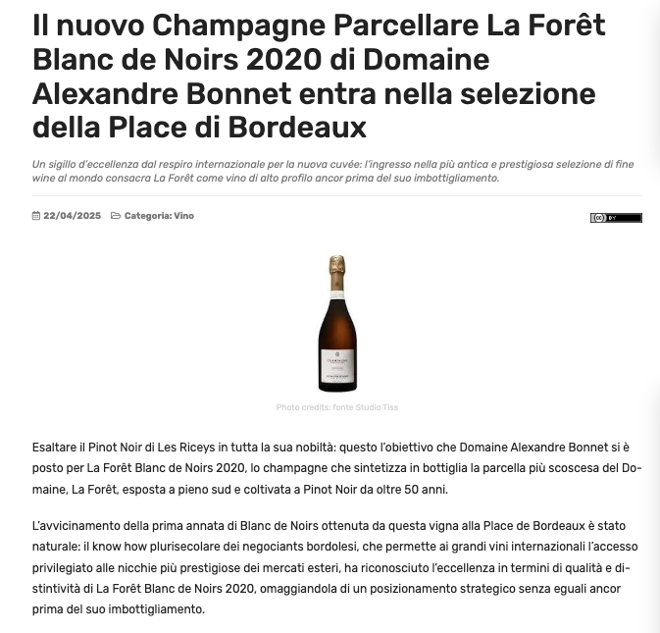
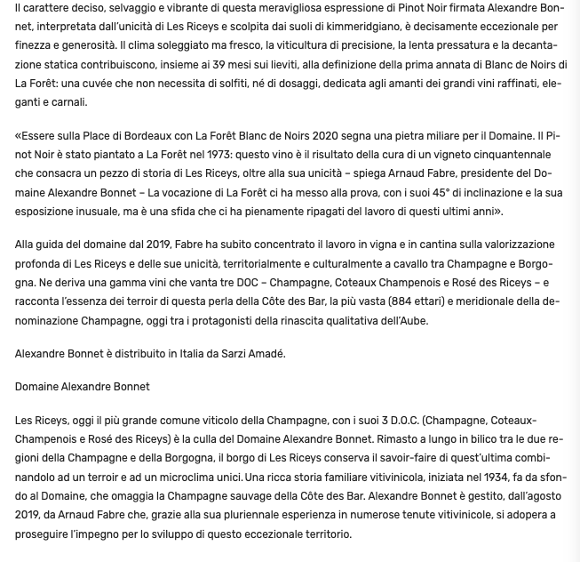
Fooday.it, 22.04.2025, https://www.fooday.it/il-nuovo-champagne-parcellare-la-foret-blanc-de-noirs-2020-di-domaine-alexandre-bonnet-entra-nella-selezione-della-place-di-bordeaux.html

